**Steps to Create an Account, Family Account, to Register a Session, and Payment**

I.

**Creating an Account**:

1.

2.

Click “**Create an Account**”: If you are a First Time User

3.

3.

Fill-out the “Login Credentials” Form, and click Create User

Page | 1

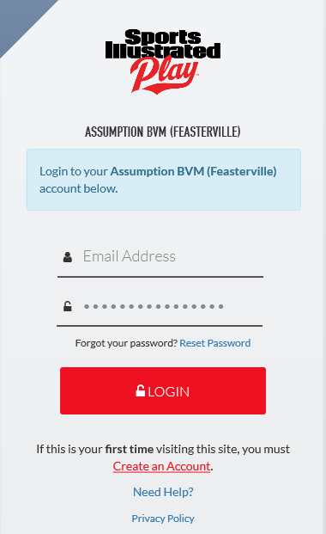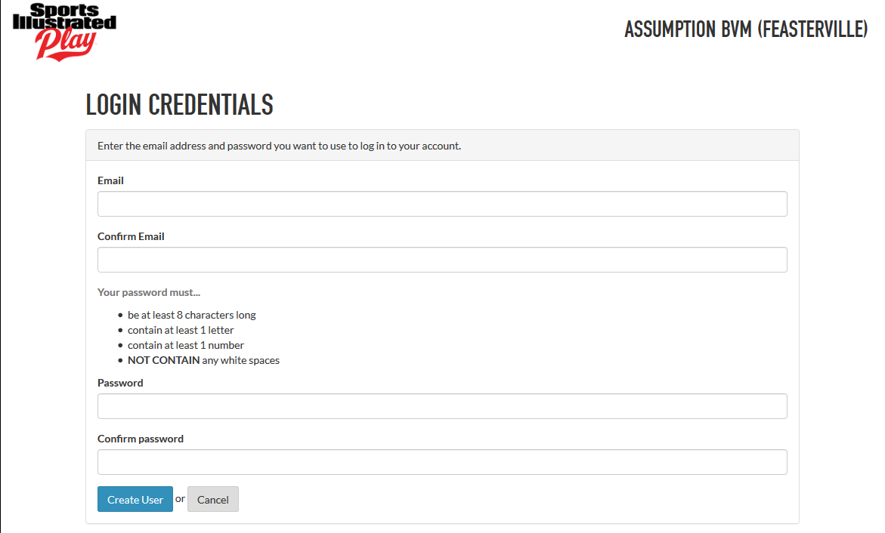

Go to [http://assumptionbvmfeasterville.website.siplay.com/](https://identity.siplay.com/account/login?returnUrl=%2Fconnect%2Fauthorize%2Fcallback%3Fclient_id%3DSSUApp%26response_mode%3Dform_post%26response_type%3Dcode%2520id_token%26scope%3Dopenid%2520profile%2520offline_access%2520Authorization%2520IdentityAPI%26state%3DOpenIdConnect.AuthenticationProperties%253DuBVCx46lt-Qu3iReY100WXXZBRooIY9lejXtTrysk0BMJvf0ntq5nZcXI2om5MSiTg6cw5ZxLQLjRS5Rc31Z125b6mWNwc46U8k-XV6jLAKRSEjLnVLSUYgS_baPZtj1I3g6B7_331nSo0r5eSr5wpQ3lqkS-9zYyhuslU8Xf5htL5WYMx0NECspGE_a_bbkMIHNXA%26nonce%3D636823064579535074.ZTA3OTU0ZGYtOTg3Zi00NjJjLWE4MjQtNTRhMWMzNmVlODU3M2MyMDFiYmMtNThkOC00ZjU2LWI0Y2QtMzQ4MTNhMDE4Y2U2%26redirect_uri%3Dhttps%253A%252F%252Fassumptionbvmfeasterville.siplay.com%252FLogin%252FAuthenticate%253FisImpersonation%253DFalse). Click “Registration” Box

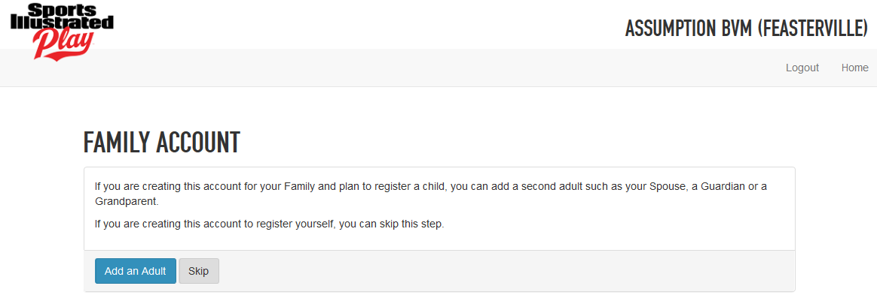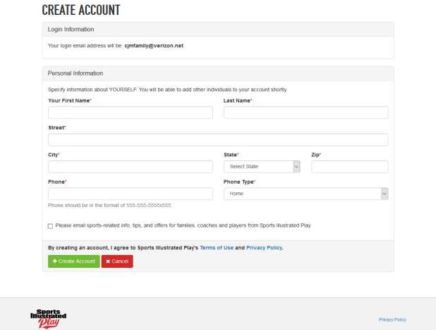

4.

Fill-out the Create Your Account, and click

Create Account:

II.

**Creating a Family Account**:

1.

Click Add an Adult

if you are creating a Family Account to register a child(ren).

Page | 2

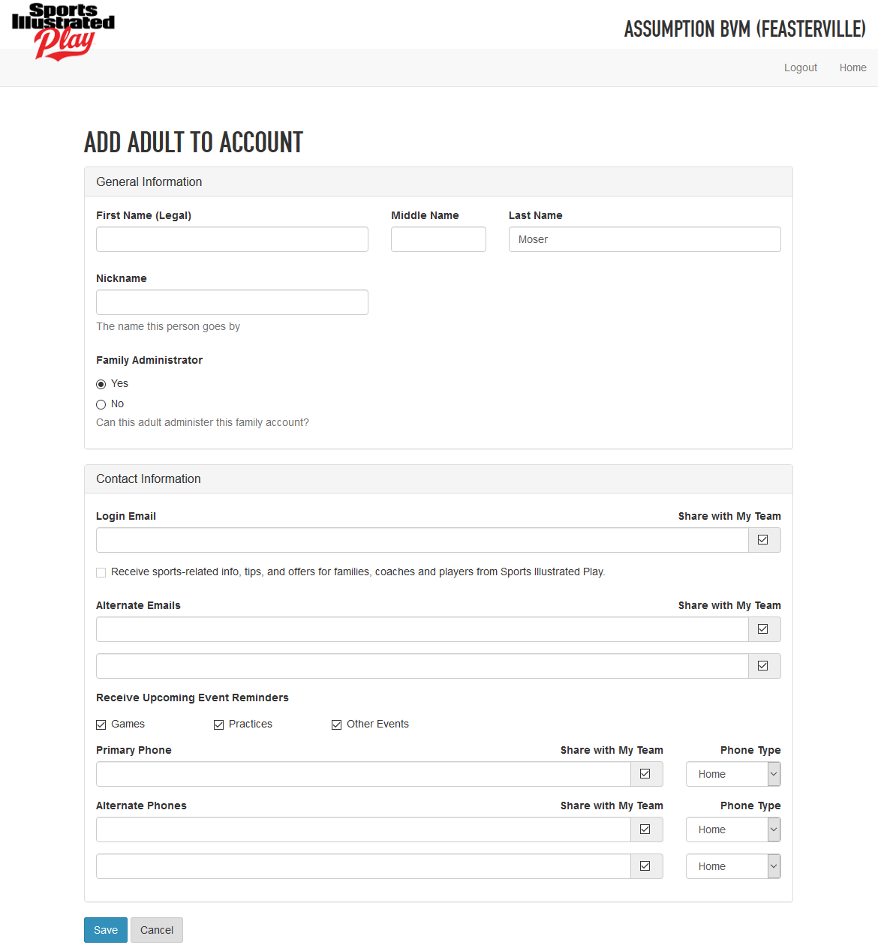

2.

Fill-out “Adult to Account Form”, and click Save

:

Page | 3

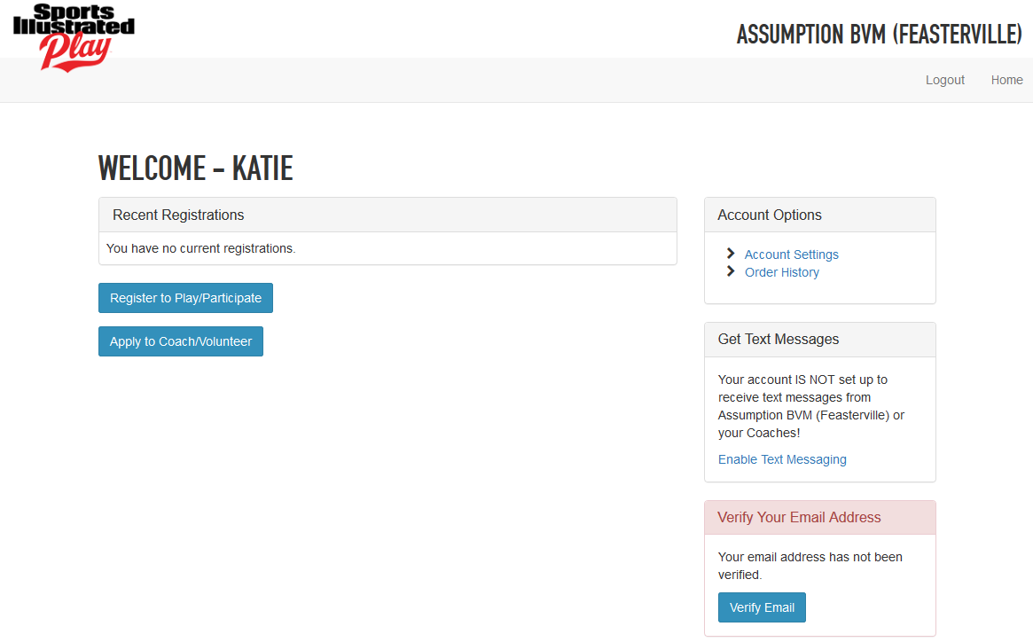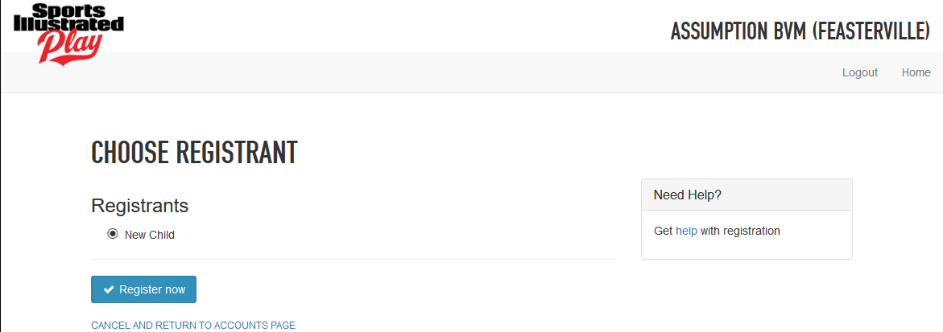

3.

Click Register to Play/Participate

:

4.

Choose “New Child,” and click Register now

:

Page | 4



5.

Fill-out “Add Child to Account,” and click Save

:

6.

Click “Home”

to add another child to your Family Account.

Go to Page 6 for “Steps to

Register and Make Payment” to register a Session(s) and to make payment.

7. Repeat Steps 4 and 5 to Add Another Child.

Page | 5

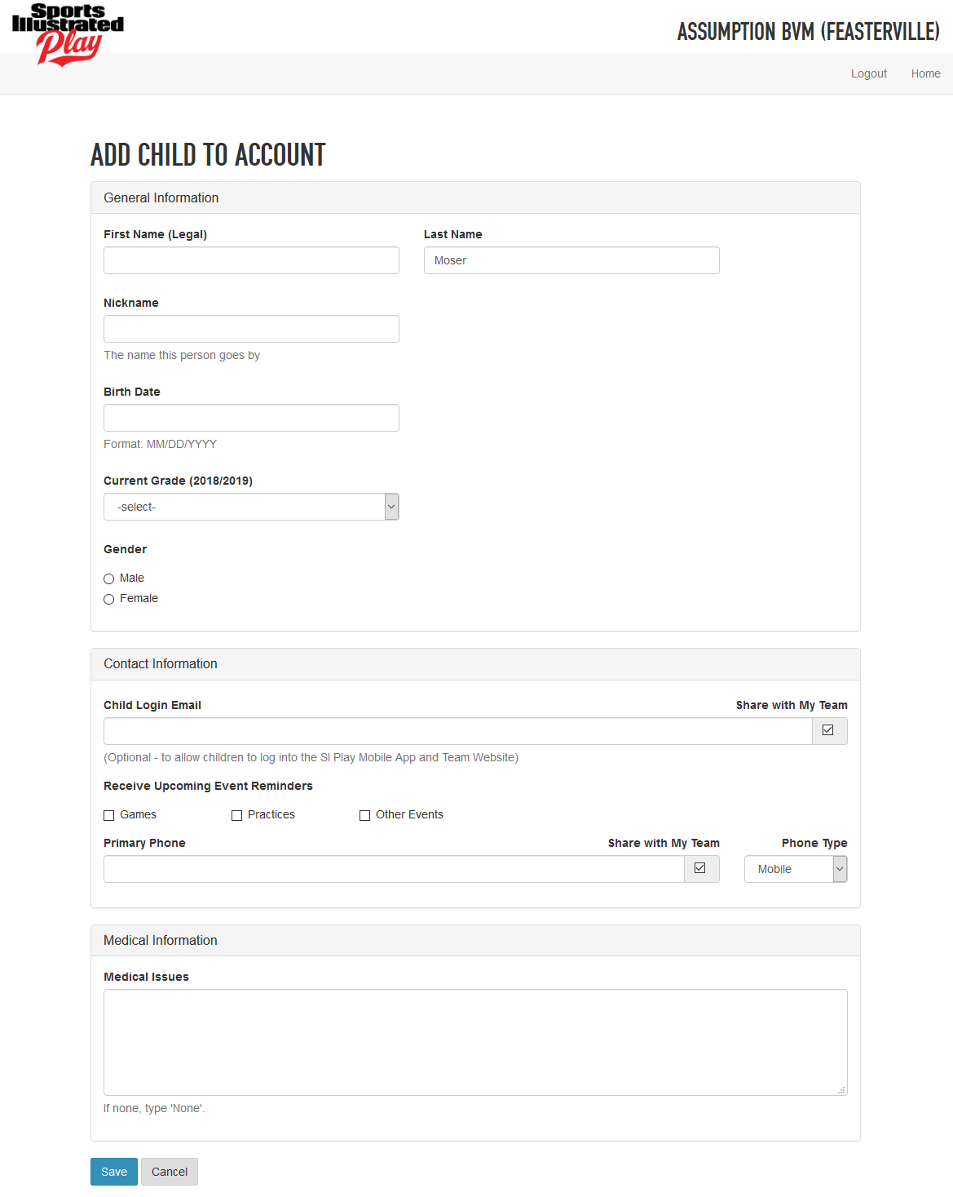



III.

**Register a Session (Sports)**:

1.

From Your Home Account Page, click Register to Play/Participate

:

2.

Choose which Registrants to register, and click

:

Page | 6

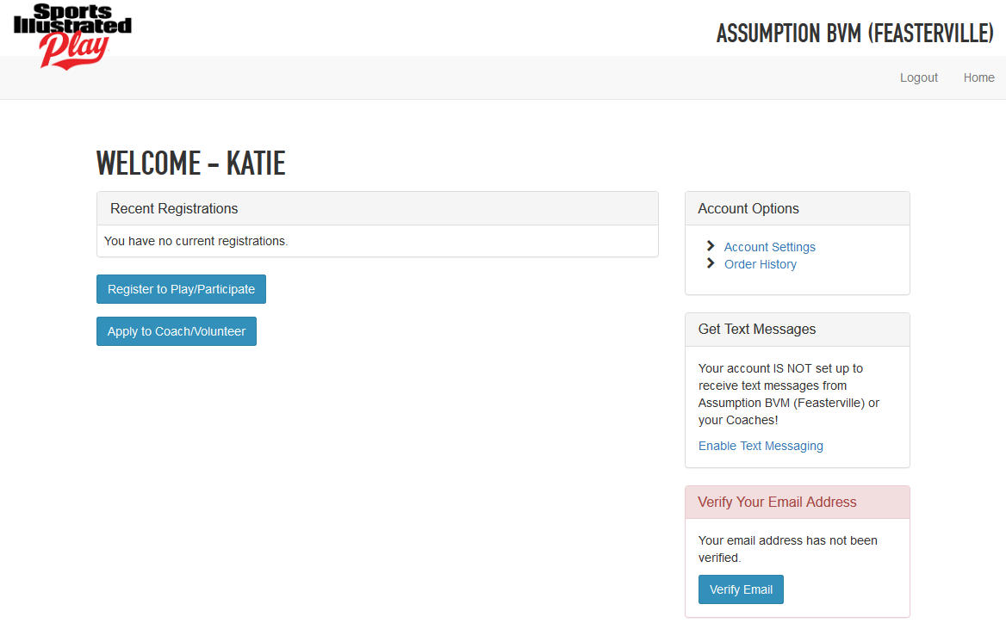

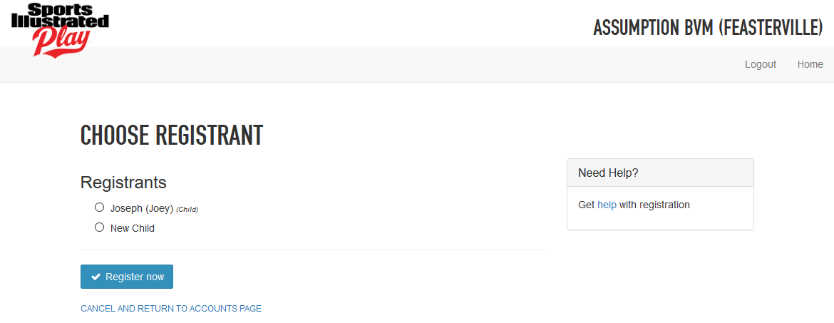

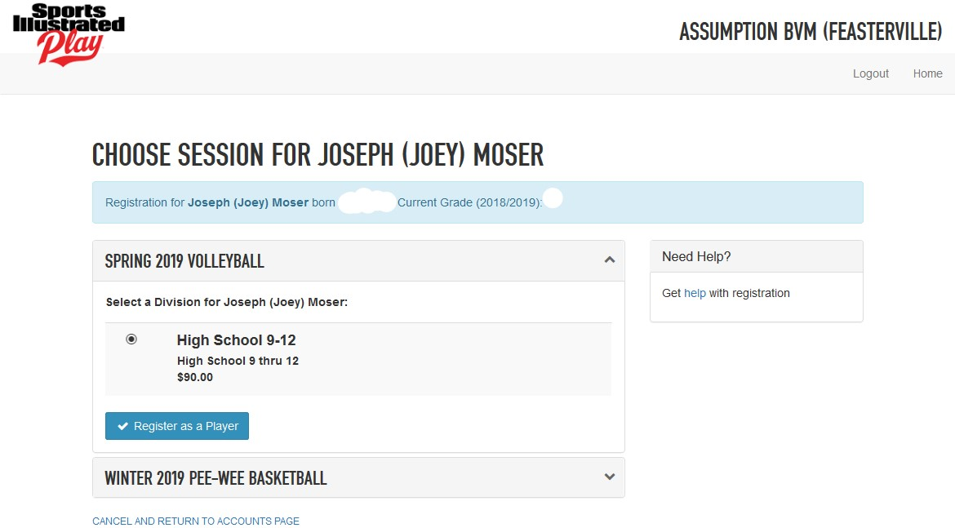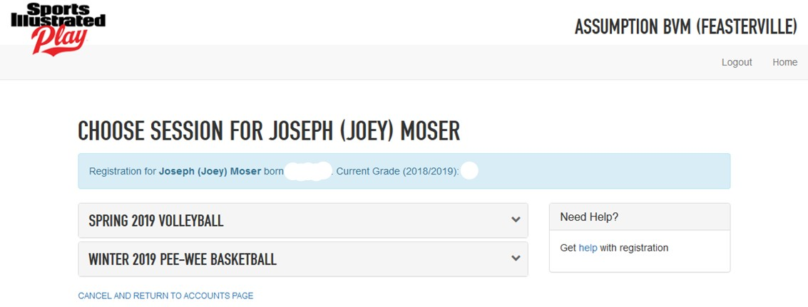

Click the  next to the Sport box to see what Division (level) to register.

3.

4.

Click Register as a Player

:

Page | 7

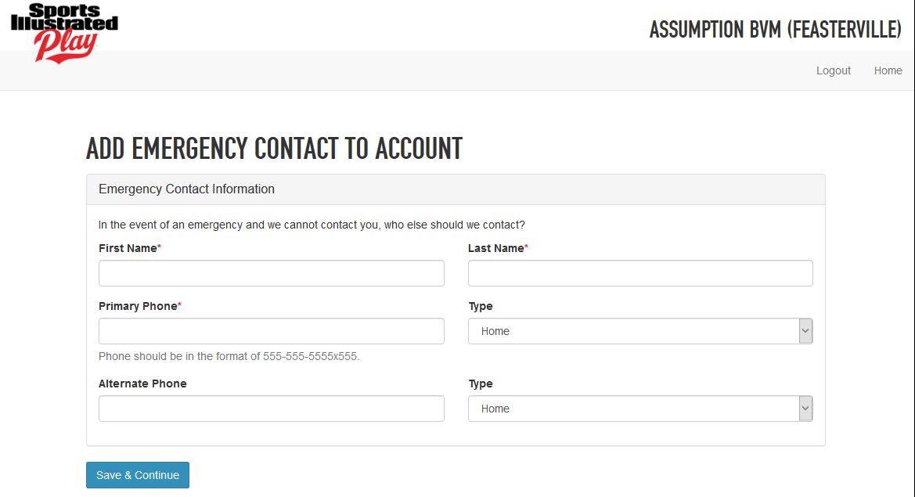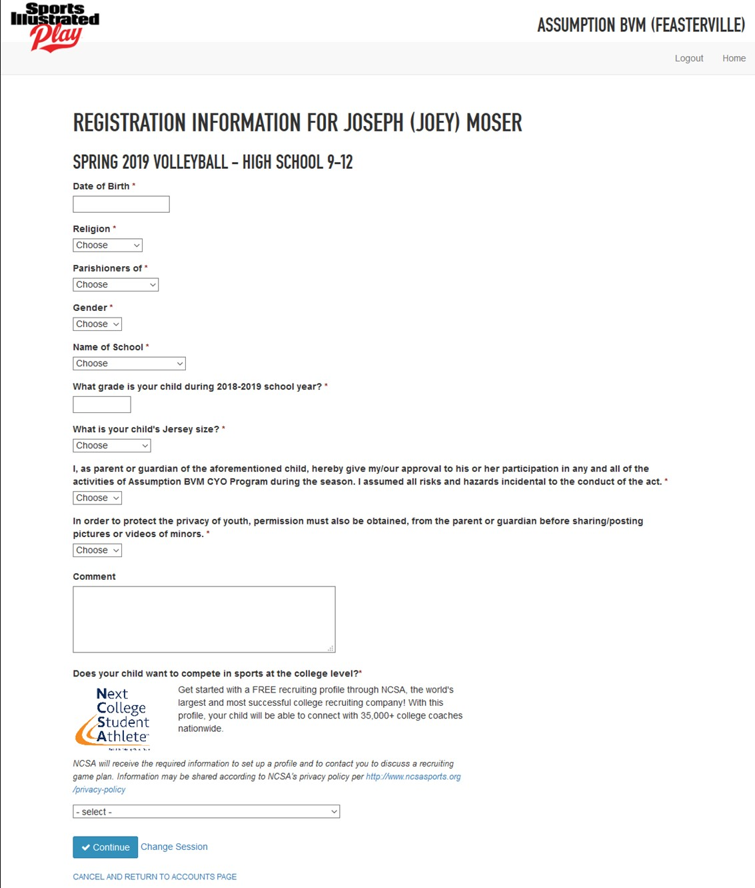

5.

Fill-out “Registration Information” Form, and click Continue

:

6.

Fill-out “Emergency Contact Account” Form, and click Save & Continue

:

Page | 8

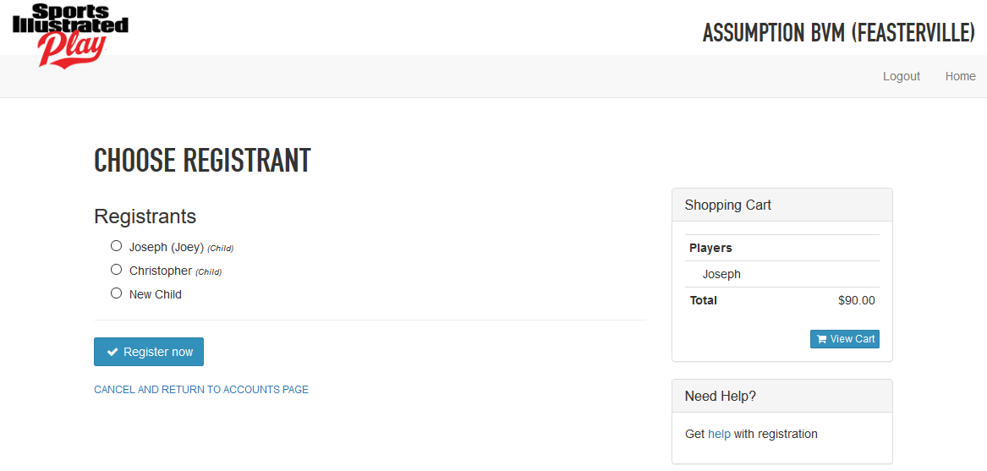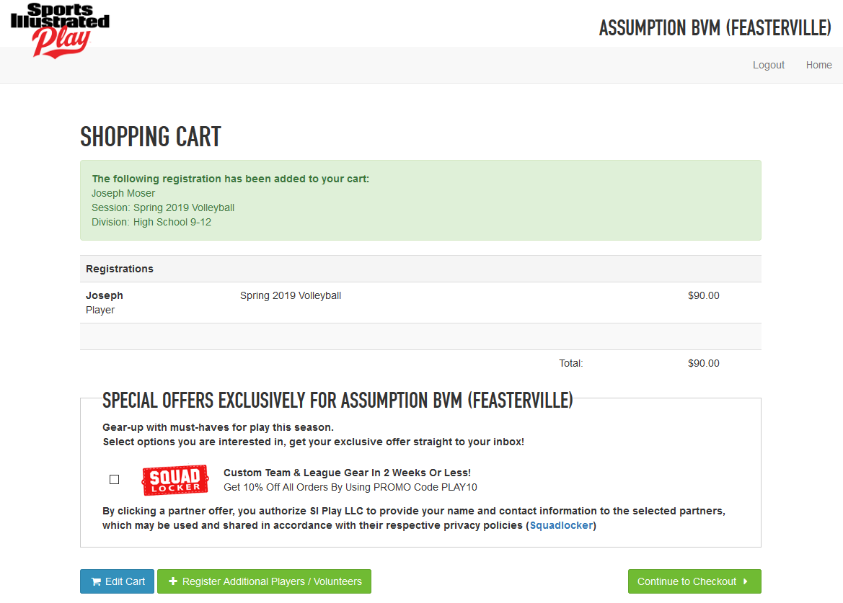

7.

If you have multiple children (players) to register, then click Register Additional Players/Volunteer

OR to continue Checkout steps, please go to page 11.

8.

Choose another child (registrant), and click Register now Shopping Cart Box on the side of what’s in the cart.

.

You will notice your

Page | 9

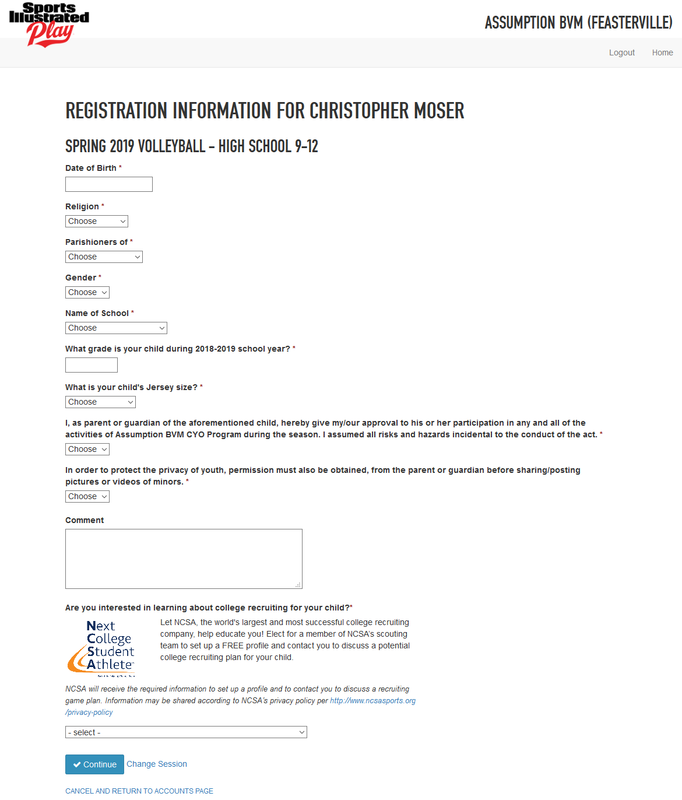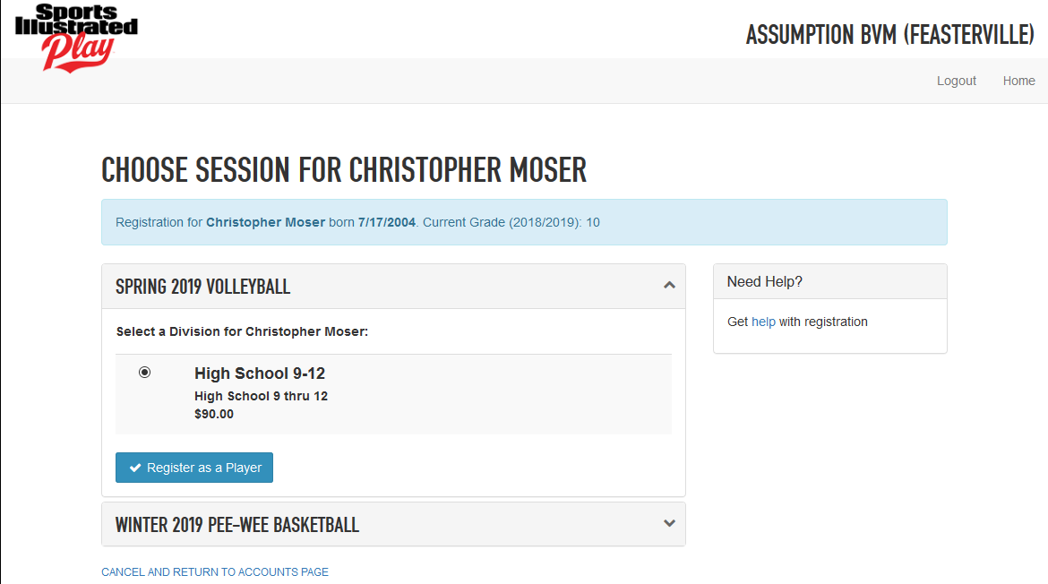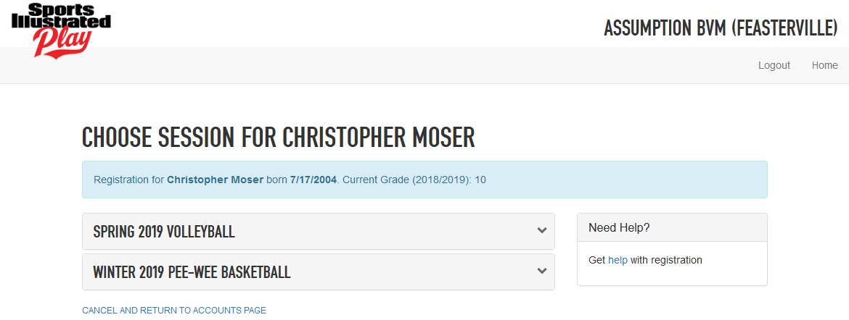

9.

Repeat Steps 3, 4, and 5:

(Step 3)

(Step 4)

(Step 5) and click Continue

Page | 10



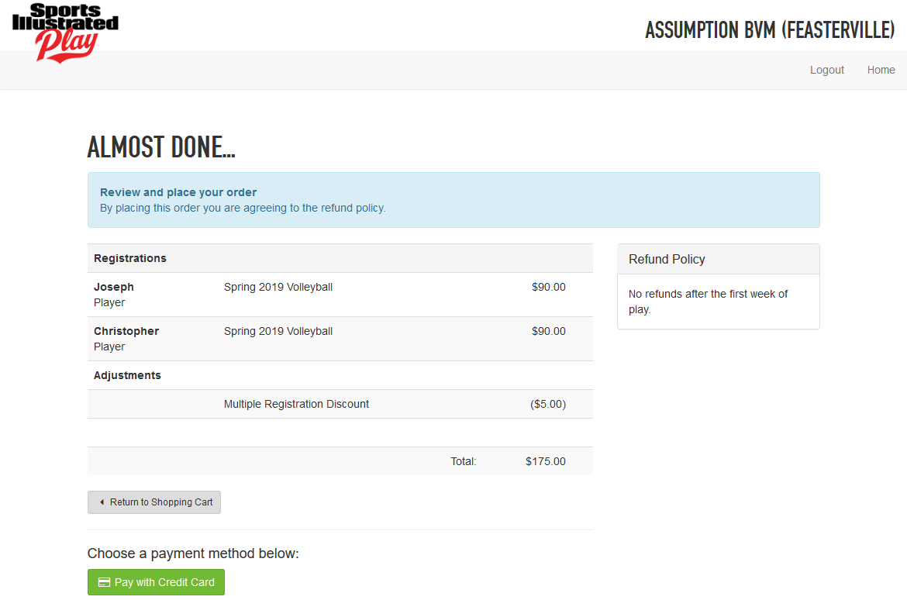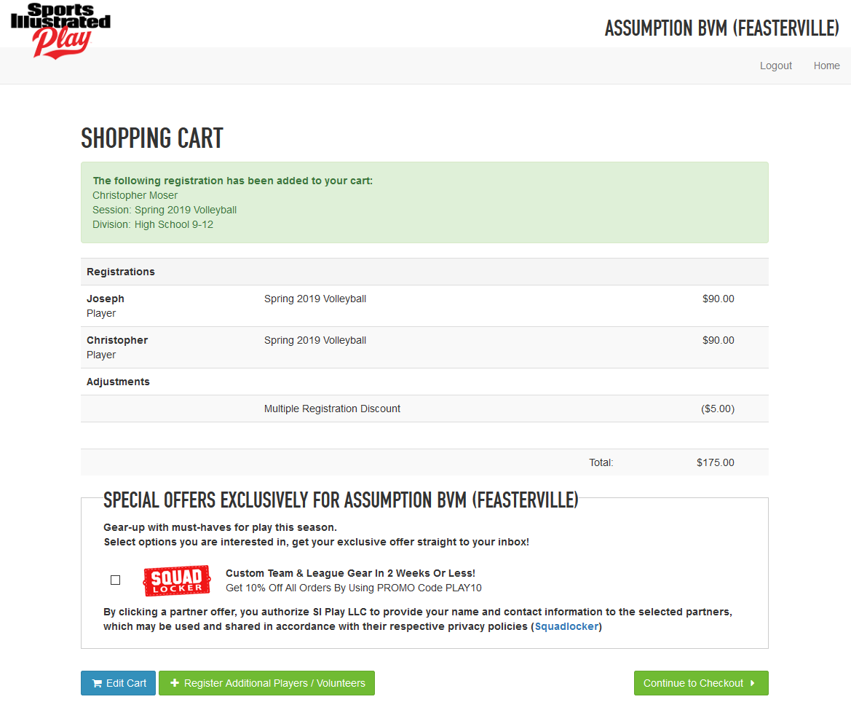

10. Either you click “Home,” and Repeat the Steps of 3 – 5 for additional players OR follow the Payment Instructions below.

IV.

**Payments**:

1.

Click Continue to Checkout

:

2.

Click Pay with Credit Card

:

Page | 11

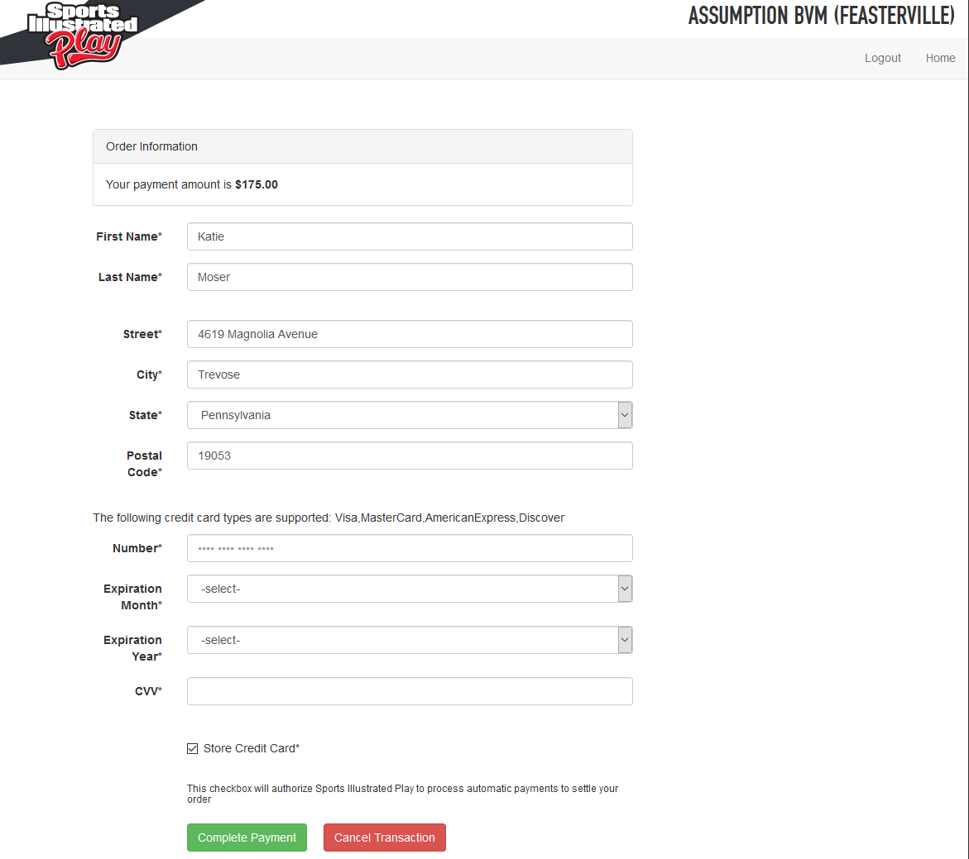

3.

Fill-out the Payment Form, and click

:

Page | 12